**Lab Assignment 10**

**AP21110010302**

**Krish Srivastava**

**CSE – E  
Network Security – CSE 315L**

1. So first we can create a private key and a Certificate Signing Request(CSR) using OpenSSL:

**openssl req -newkey rsa:2048 -nodes -keyout domain.key -out domain.csr**

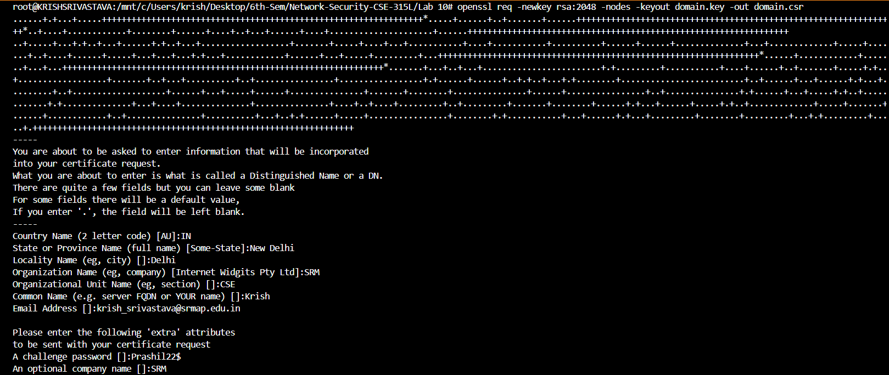

1. Then we will create a self-signed certificate.

**openssl x509 -signkey domain.key -in domain.csr -req -days 365 -out domain.crt**



1. Now we are testing locally so we can configure it on a local server ( I used flask)

from flask import Flask

app = Flask(__name__)

if __name__ == "__main__":

    app.run(ssl_context=('C:/Users/krish/Desktop/6th-Sem/Network-Security-CSE-315L/Lab 10/domain.crt', 'C:/Users/krish/Desktop/6th-Sem/Network-Security-CSE-315L/Lab 10/domain.key'))

1. Running the local server using : **python app.py** where app.py has the above code.

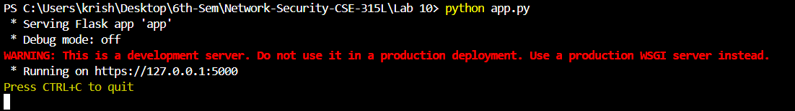

1. The following certificate is visible on the web browser:

